UNIFORM SHOP ORDER FORM

Please order online (pay online and email a completed order form to the school email address nbscbalgb-h.school@det.nsw.edu.au). The uniform shop is open for appointments only on school days 8-9am (contact school office for appointments 9949 4200).

School Uniform | Qty | Size | Unit Price  (inc GST) | Total Price  (inc GST)
Shorts – Button Waistband | Choose quantity | Choose size | $40.00 | enter $ amount
Shorts – Elasticated Waistband | Choose quantity | Choose size | $40.00 | enter $ amount
White Polo Shirt | Choose quantity | Choose size | $30.00 | enter $ amount
Navy Polo Shirt | Choose quantity | Choose size | $30.00 | enter $ amount
Sport Shorts | Choose quantity | Choose size | $35.00 | enter $ amount
Polar Fleece | Choose quantity | Choose size | $40.00 | enter $ amount
School Cap | Choose quantity | One size | $15.00 | enter $ amount
Long Pants | Choose quantity | Choose size | $50.00 | enter $ amount
Spray Jacket | Choose quantity | Choose size | $40.00 | enter $ amount
Senior White Shirts | Choose quantity | Choose size | $30.00 | enter $ amount
Apron | Choose quantity | One size | $10.00 | enter $ amount
Band Long Sleeve Black Shirt | Choose quantity | Choose size | $30.00 | enter $ amount
Other Uniform (As notified by the Sports co-ordinator)
Sport Singlets | Choose quantity | Choose size | $25.00 | enter $ amount
Red Football/Soccer Shorts | Choose quantity | Choose size | $25.00 | enter $ amount
Uniform Sub Total (id: 158699) |  |  |  | enter $ amount
Calculators compulsory (id: 167484) | Choose quantity | N/A | $35.00 | enter $ amount
TOTAL (incl. GST) |  |  |  | enter $ amount

PAYMENT DETAILS

Date: click or tap to enter a date. Student Name/ Year: enter full name and year

Paid Online: $ enter sum (enter payment type as ‘other’, description as ‘uniform’)
Uniform will be packed the next day after payment for orders placed before 6pm
Online receipt number: enter receipt number Mobile: enter mobile number

Returns Policy: Returns accepted with proof of purchase within 14 days. Items must have original tags, packaging and be unworn.
OFFICE USE
Uniform Supplied:- Yes No Date to be collected:-
Date taken:- Date Taken:-
Signature:- Signature:-

NB. Please see overleaf for NBSC Balgowlah Boys Campus Shoe Policy

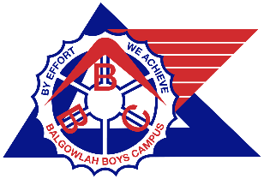
NBSC Balgowlah Boys Campus
School Shoe Policy

All boys are required to wear black leather lace up school shoes (no boots, canvas, Vans or trainers) with plain white socks.

Acceptable shoes:-

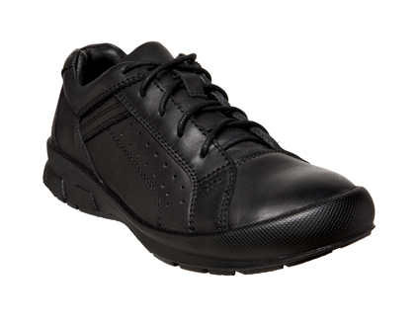
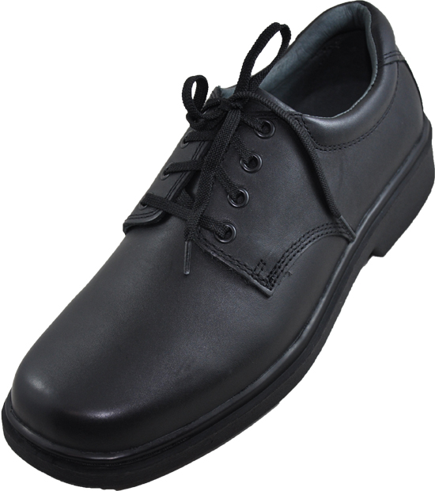

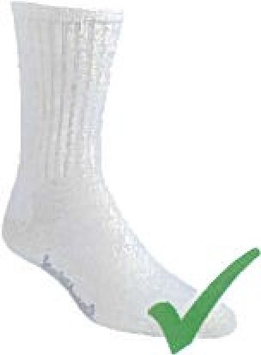

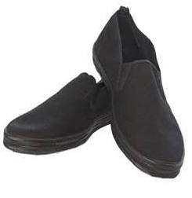
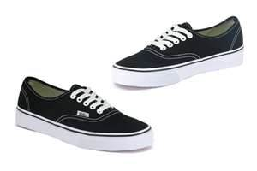
Unacceptable shoes:-

